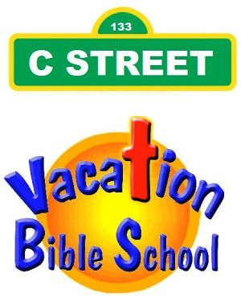
At St Paul Lutheran Church
785-258-3430
July 17th-20^{th,} 2023
9:30 a.m to 11:30 a.m.
For children of the Good Neighbor Parish from 4 through completion of the 5th grade.
Please Print

Child’s Name _______________________________________________________

Child’s Age ______Child’s Birth Date ___________Child’s Completed Grade _____

Parent/Guardian Name(s) _____________________________________________

Home phone ____________Work Phone _________Cell _____________________

Email _______________________________Preferred Contact Method __________

Emergency Information
Emergency Contact #1 ___________________________Phone ____________
Emergency Contact #2 ___________________________Phone ____________
Doctor _______________________________________Phone _____________
Allergies or special needs ____________________________________________

Parent/Signature _______________________________________________

