September 2023
Newsletter of the Good Neighbor Parish
St Paul Lutheran Church Herington
Hebron Lutheran Church Burdick
HEBRON NEWS ……….
Labor Day Worship Sept 3, 9:30 am on tennis courts in Burdick
Sept 10- God’s Work, Our Hands Sunday.
Worship at Hebron 9:30
Hebron WELCA
Thurs. Sept. 21, 2:00 pm
Hebron Church Council
Mon. Sept. 18, 7:00 pm

Prayer Concerns: The family of Skip Simons, Olivia Carlson, Robin Pritz, Tom Cain, Ethan Lif, Bob Novak, Kinsley Shoup, Lisa Hanschu, Randy Mai, Jeff Peterson, Pastor Bill & Judy Peterson

Homebound: Naomi Nelson, Roger Peterson, Jewell Swinney, Hallie Novak, Maxine Barton

Hebron Council
Tana Riffel - President – 258-0131
Amber Peterson Secretary 366-6721
Connie Johnson –Treasurer 466-6465
Tom Remy – Finance Sec 983-4828
Andy Carlson – 466-6571

Hebron Birthdays
1 Pam Ackley
3 Ashley Carlson
4 Josie Whacker
14 Spencer Hedstrom
16 Steven Hageberg
16 Steve Schild
17 Kaden Hutchison
18 Becky Hedstrom
20 Bruce Hedstrom
26 Chris Peterson
28 Adriane Richard
29 Diane Ecklund

Anniversaries – none

Contact Information for:
Good Neighbor Parish
Hebron / St. Paul
Lutheran Churches
Pastor Jim Peters

Cell phone: 785-215-3535
Church Office: 785-258-3430
Email: church0720@att.net
Pastor Jim pastorj0720@att.net

Website: stpaulheringtonkansas.com

“What you say flows from what is in your heart.”
Luke 6:45 (NLT)

From the Pastor
This Photo by Unknown Author is licensed under CC BY
Happy fall, y’all!
There have been a few times when I’ve been asked if I think our pets will be with us when we go to heaven. The most honest answer I can give to that question is, “I don’t know.”
I know there are some who would say the answer should be “no,” because animals don’t have souls. But if you’ve ever felt the love of a special pet, I can understand why you would ask that question. When a special pet dies, we need to grieve their loss just as much as we grieve the loss of family members and friends.
This month we’ll be sharing a scripture that tells us that the answer just might be “yes.” On Sunday, September 24th, our first reading will be the conclusion of the book of the prophet Jonah. In the very last line of the book, and of the reading, God is telling Jonah about God’s concern for the city of Nineveh, a city of over a hundred and twenty thousand persons who don’t know their right hand from their left, and also many animals.
That one line has always affirmed for me that God cares about animals. And if God cares about animals…well, then, maybe! I hope so!
That’s kind of a roundabout way of letting you know that I plan to offer a blessing of animals at church during worship on Sunday, October 1. But it’s not the sort of blessing where you’ll need to bring your animals to church with you.
Instead, I’d like to invite you to share a picture of your pets or of the animals under your care. For those of you who care for a lot of animals, a representative photo will do. Ideally, you’ll be able to take a picture with your phone or digital camera and e-mail the photo to me at pastorj0720@att.net. If that’s not possible, you can submit an actual photo to me, though if you do that, please make sure you submit it in an envelope with your name on it so that I can be sure to get the photo back to you.
I hope to include these photos in a slideshow to be shown before church begins on October 1. If you’d like to participate, please submit your photos to me before Monday, September 25. Worship that day will not only include the photos, but also a prayer for our pets and all the animals under our care.
The blessing of animals often occurs at this time of the year because the church remembers Francis of Assisi on October 4, and one of the things Francis is known for is recognizing animals as his brothers and sisters. We also recognize God’s gift of animals and special pets in our lives, and so it’s appropriate that we ask God’s blessings upon them.
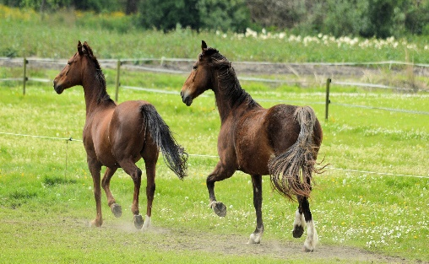
I hope you will consider being a part of this celebration! And I hope God will bless and enrich you as we begin this new season together!
Pastor Jim

St. Paul September Birthdays
Hunter Haws 7
Marcia Mathias 8
Carol Miller 8
Keith Albrecht 10
Linda Carlson 13
Carol Schubert 18
Kathy Castleberry 24
Dan Nelson 24
Ella Nelson 24
Brooks Gehrke 28
Dale Kleinschmidt 30
Craig Wendt 30

St. Paul September
Anniversaries

Jason & Brandee Gentz 1
Frank & Shirley Meyer 6
Tate and Kailyn Becker 25

2023 St Paul Council

Dan Nelson 913-909-0503
Megan Mein 913-209-2065
Karen Donahue 785-258-4567
Julie Albrecht 785-258-0047
Debbie Wendt 785-258-0144
Roger Engle 785-258-2548
Dede Patterson 785-221-5586
Jennie Wilson 785-366-3540

Prayer Concerns: Rita Gehrke, Aaron Unruh, Vance Donahue, Nita Pritz, Avery Korgol, Delores Granzow, Robin Pritz, Jason Moore, Ron Fehr, Aleda Koepke, Charlie Everhart, Alice Peterson, Bill and Judy Peterson, Bob and Hallie Novak, Hazel Wendt, Mildred Gehrke, Jill Granzow and all of our homebound.

This Photo by Unknown Author is licensed under CC BY-NC-ND

Sunday School will resume at St Paul in September for all students from preschool-5th grade. On September 10, we will have God’s Work, Our Hands and Sunday School Registration. Sunday School Classes will begin on September 17th.at 9:45 a.m. Please invite your friends. All are welcome!

Minutes of the St. Paul Lutheran Church Council Meeting
06/20/2023
Members Present: Karen Donahue, Roger Engle, Dan Nelson, Dede Patterson, Pastor Jim Peters, Debbie Wendt, Jennifer Wilson Not present: Julie Albrecht, Megan Mein
Guests: Tana Riffel
President Dan Nelson called the meeting to order at 6:08 pm.
The meeting was opened with devotions provided by Dan.
The minutes of the 05/16/2023 council meeting were read. Some updates were made to the minutes to clarify the agreed upon salary is not an annual salary but is for the remainder of the year. Jennifer motioned for approval, Karen seconded. The minutes were approved with updates.
Financials – Debbie discussed the financials as of 05/31/2023. Portico bill received May and June – covered pension and disability. May’s expense is not accurate for Pastor’s salary. Housing allowance needs to be paid through accounts payable and will be adjusted in June and going forward. Debbie noted that nothing was budgeted for housing allowance so the comparison between actual and budgets will be unusual for the year.
Pastor’s Report – Discussed the June 24th wedding held at St Paul but not officiated by Pastor Peters. Someone suggested that Megan will be in attendance to ensure the wedding party has what they need. The Pastor shared that his schedule for the week of July 3 will include Wednesday through Friday instead of Monday through Wednesday. A comment of appreciation for one of Pastor’s home visits was voiced.
Unfinished Business
Carpet/Tile Cleaning – More discussion will be held at the July meeting regarding the tile floors.
Interim Consultant Pastor Peter Rehwaldt –Dan had a conversation with Pastor Rehwaldt regarding the consultant fees and the difficulty the parish would have in meeting the additional expense. The Central States Synod has grant money that can help congregations in need. The Synod would match what we can afford. Dan discussed with Tana and they suggested $600 a month from parish and $600 from Synod to pay Pastor Rehwaldt for the consultant fees. In addition, the Parish would be responsible for travel expenses. Dan provided the interim consultant agreement for consideration and made a motion to accept the proposal. Jennifer seconded. The council, along with Tana Riffel (Hebron), approved the proposal. Transition Team membership was discussed and members will be finalized before the first workshop that is proposed for July 29-30.

New Business –
Pastor Jim Peters’ Housing Allowance – Dan provided the housing allowance declaration designating $18,000 of the salary as housing allowance. Dan made a motion to accept the declaration, Jennifer seconded. All approved.
Internet Access for the Parsonage – Dan contacted Vyve and they can provide internet for $59.99/month that can be cancelled at any time. Dan made a motion that the church provide internet at the parsonage. Roger seconded. All approved.
Pastor Party July 23rd – Church will provide chicken and members will bring side dishes and desserts. Marcia and Corkie will communicate to the congregation.
Fair Booth & Parade – The cost is $40 to rent the booth. Pastor Peters offered to sit at the booth and church members will be asked to participate. The parade is on Friday night, July 7, and Dan will inquire to see if there is interest in participating in the parade.
The next meeting will be July 16, 2023 at “The Cabin” at 5:30 PM. Dan will provide a meat and council members will bring side dishes and desserts.
The meeting was closed with the Lord’s Prayer.

There was no business conducted at the July meeting at the cabin.

God’s Work Our Hands
Has been scheduled for September 10, 2023. We will meet at church and then scatter out to do God’s work in the community. Be thinking about what you can do to help. For those wishing to do a regular worship service you may join the regular service at Burdick at 9:30 a.m. We have a few Tshirts available in limited sizes if you need one. Contact the church office. 258-3430.
St Paul Council will serve breakfast at 8:00a.m. in fellowship hall. We are planning on doing some outside clean up yardwork, packing care kits, doing free oil changes and servicing garage doors. We will be focusing on working out in the community.

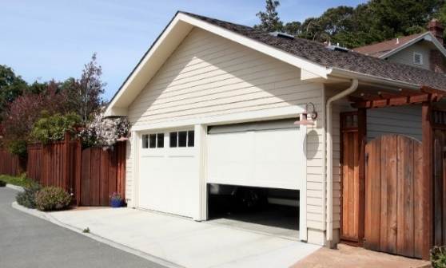

GARAGE DOOR SERVICES
Once again, Dale Kleinschmidt will be taking a helper and servicing garage doors for our elderly in the community on “God’s Work, our Hands” Sunday. Be sure to get on the list for that service. You don’t need to be a St. Paul member so if you know someone needing this service, be sure to let them know.

FREE OIL CHANGES
Free oil changes Craig Wendt will again be doing free oil and filter changes for God’s Work, Our Hands. Thrivent will be helping to fund the oil and filter purchases. (Cars only) If you know of someone who would benefit from this service, please call Marcia in the church office at 258-3430 or her cell at 258-0218. We will pick up your car, change your oil and filter, check anti freeze and tire pressure and return it. You will need to make your appointment by September 1st to have your car serviced on Sunday, September 10th.
No diesel vehicles please.
Participants can get forms to sign up at FRE or the church office. First come, first serve. You do not need to be a member of St Paul to take advantage of this.

Personal Care Kits
Dede will be leading a group at church in packing the personal care kits that we send to Lutheran World Relief.

Yard Work
We will need a few to go out into the community and help with trimming bushes, weeds, low limbs, etc. Please sign up to help.

$$$$$$$$$$$$$$
July 31, 2023
Budgeted Contributions:
$94,720.50
Actual : $85,358.89

Expenses Budgeted: 94,720.50
Actual: 71,272.50

Thank you to all who are mailing in your contributions
when you can’t be here.

.

Back to School Blessings

We had a special blessing and prayers for all students and teachers on August 13th during regular worship service. Our prayers for a safe and happy school year for all.

Hoping to plan a “Good Cleaning of the Church Day” this fall. Suggestions welcomed. Please plan to help.
Our deepest sympathy goes out to the families of Gary “Moe” Solomon and Naomi Snyder whose funerals were at St Paul on August 3rd and 10th. May
God’s peace be with them.
Did you know?
St. Paul weekly Sunday morning worship service is recorded and broadcast live on our website? Just go to stpaulheringtonkansas.com. There is a red bar on the home page that says “Watch Service Videos” Click on it and there you will see our services.

“Those who eat my flesh and drink my blood abide in me, and I in them.”
Celebrate the Lord’s supper.

Our Gold Pot offering in August collected
$51.09
for the Family Resource Exchange to help local families with school supplies or back to school expenses. The September Gold Pot is designated to help with shipping costs of quilts and personal care kits for Lutheran World Relief.

“Truly I tell you, whatever you did for one of the least of these brothers and sisters, you did for me”
Matthew 25:40

Meals on Wheels will be delivered by St Paul volunteers September 11th-15th.This takes about one to one and a half hours and is a ministry of our church. Could you spare a little time to help out? It is once every four weeks.

BACK TO SCHOOL PRAYER
God of wisdom and might, we praise you for the wonder of our being, for mind, body and spirit.

There are so many things to be anxious about. Be with our children as they begin this new school year. Bless them and their teachers and staff. Give them strength and grace as their bodies grow; wisdom and knowledge to their minds as they search for understanding; and peace and zeal to their hearts. We ask this through Jesus Christ, our Lord. Amen.

Confirmation
Confirmation classes led by Pastor Jim will begin on September 17th immediately after worship. Classes will last 45 minutes – one hour. If you know of someone who would like to come to our confirmation classes, please invite them.

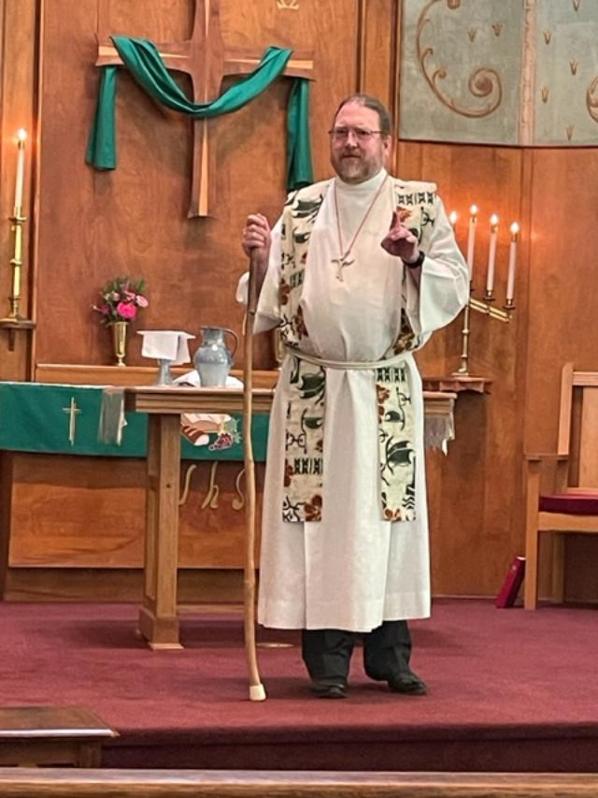

Consultant Pastor Peter Rehwaldt

The meeting and meal with consultant, Pastor Peter Rehwaldt was on Sunday,
August 20th at St.Paul. Pastor Rehwaldt delivered a powerful message at both worship services. A luncheon for 76 people followed at St Paul for members of both churches . Thank you to all who attended. There will be some important decisions to make by our congregation regarding transitioning of pastors during the next few months. Pastor Rehwaldt’s job is to help guide us in making those decisions. Pastor Rehwaldt will be here on September 17th to meet with us again.

This is God’s house. It is a house of prayer.
“ALL ARE WELCOME!”
ADULT SUNDAY SCHOOL - A new study will begin Sunday, September 17, 2023. We meet each Sunday at 9:30 a.m.
“The end of the world. How do you react to that thought? Does it make you afraid? Excited? Nervous? Full of anticipation? Full of peace? The apostle John was privileged to preview the end of the world. …” Max Lucado’s Life Lessons from Revelation will be the resource for our small group. If you are interested in joining the discussion and would like a book (cost is less than $10), please contact Dede Patterson. (785-221-5586)
Deadline to order is September 6th. We welcome more voices in our discussions!

To all who helped in August with funerals, fellowship and our Nacho plate dinner . It seems like there have been a lot of meals served here in the last month! Thank you also to those who brought food and helped serve and clean up.

“What you say flows from what is in your heart.”
Luke 6:45 (NLT)

On-line Engagement
with the Bishop

We’re going to put that new TV downstairs to work and join Bishop Candea for a presentation on Sept 19th from 6:30- 9:00 p.m.

We will explore:
What’s church got to do with it?
- Why do we even need the church?
- What is the purpose of denominations?
- What does it mean to be part of the ELCA?

Do you even feel like you are part of the ELCA or does it seem like some office in Chicago with little or no connection to our local congregation, let alone our faith in Christ?

Bishop Candea will present information regarding the purpose of the church and denominations, as well as the interdependent relationship with the ELCA. There will be opportunity to ask questions and for discussion of both the gifts and the challenges of being part of the ELCA.
We will conclude by focusing on our local context and learning more about congregation vitality, ways to engage in practices that enhance the ministry we are called to do in our communities.

No registration is required. This is a webinar for all. We hope you will take the time to learn more and to deepen our discipleship as we continue to travel the way of Jesus together.

We are packaging Personal Care Kits for Lutheran World Relief on God's Work Our Hands Sunday. The items included in the Kits are:
- Light-weight bath-size towel (between 20” x 40” and 52” x 27”), dark color
- Bath-size bars of soap equaling 8 to 9 oz., any brand, in original wrapping
- Adult-size toothbrush in its original packaging
- Sturdy comb
- Metal nail clippers (attached file optional)

Would you like to help by contributing to supplies? If you're interested in helping with the supplies, please bring them to church by Sunday, September 3rd so shopping for the remaining items can be completed before GWOH Sunday.
This Photo by Unknown Author is licensed under CC BY-SA
September 2023 2018
Sunday | Monday | Tuesday | Wednesday | Thursday | Friday | Saturday
Hebron Lutheran worship = 9:30 am
St. Paul Lutheran worship = 11:00 am Fellowship following worship
Sunday School Registration September 10
 |  |  |  |  | 1 | 2
3  9:30  Hebron Worship at tennis courts  11:00 St. Paul worship | 4  Labor Day  Office Closed | 5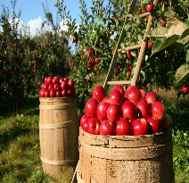 | 6 | 7 | 8 | 9
10  God’s Work Our Hands  8:00 Breakfast provided by Council  9:30 Hebron Worship  Sun School registration | 11  Meals on Wheels | 12  Meals on Wheels | 12  Meals on Wheels | 14  Meals on Wheels | 15  Meals on Wheels | 16
17  9:30 Hebron Worship  11:00 St. Paul worship  Gold Pot for Lutheran World Relief  Shipping Cost  Pastor Rehwaldt here  Sun School and confirmation start | 18  7:00 Hebron Council | 19  6:30-8:00  Webinar with Bishop Candea  In St Paul basement | 20 | 21  2:00  Hebron  WELCA | 22 | 23
24  9:30 Hebron Worship  11:00 St. Paul worship | 25 | 26 | 27 | 28 | 29 | 30
October 1st- “Blessing of the Animals”
September Servant Schedule

2023 | Sept. 3 | Sept.10 | Sept. 17 | Sept. 24 | Oct. 1 | Oct. 8
Communion Asst. | Corkie Dunlap | God’s Work  Our Hands  Sunday | Dale Kleinschmidt | Andrea Nelson | Vanessa Lawrenz | Lisa Beye
Song Leader | Dory Olsen | None | Dory Olsen | Bre Fry | Dory Olsen | Bre Fry
Acolyte | Henry Nelson | NONE | Jocelyn Lawrenz | Ella Nelson | Raquel Lawrenz | Hadley Friedli
Greeters | Corkie Dunlap  Rodney & Dawn Wilson | Wear your yellow  t-shirt | Verl & Karolyn Schlesener  Deb and Carl Urbanek | Craig Wendt  Marcia  Mathias  Peggy Hilliard | Debbie Wendt  B. Federle  Conne Gentz | Henry & Dan Nelson  Jennifer Wilson  Joyce Loe
Reader | Cindy Roberts | None | Karen Donahue | Marcia Mathias | Gary Schubert | Lisa Beye
Counters | Rodney & Dawn Wilson  Vanessa Lawrenz | Breakfast at 8:00 am  Church basement | Verl & Karolyn Schlesener  Carl & Deb Urbanek | Craig Wendt  Marcia Mathias  Dave & Rita Gehrke | Debbie Wendt  Keith & Julie Albrecht | Roger & Jayne Engel  Willis Bernhardt
Altar Guild | Cindy Roberts | Doing God’s work work | Cindy Roberts | Cindy Roberts | Gary & Carol Schubert | Gary & Carol Schubert
Sound Crew | Jennifer Wilson  Rodney Wilson | In the community | Henry Nelson  Tanner Becker | Dale Diepenbrock  Tanner Becker | Jennie Wilson  Tanner Becker | Tanner and Cinta Becker  .

Notice for Lay Servants: If you can’t serve as scheduled please find someone on the schedule that would trade with you. Then, please call the church office to let Marcia know you have changed and with whom. Thank you for your cooperation.

Good Neighbor Parish Non-Profit Organization
114 North 8th Street
Herington, KS 67449
September 2023
(785-258-3430)

Hebron 9:30 am Worship
St. Paul = 9:30 am Adult Ed.
11:00 am Worship

MARCH
2019 2019

Welcome September

